Set 5: Website Analytics
1.Line Chart:
Aim: To create a line chart using R to visualize the trend in daily page views over time.
Program:
# Create Website Traffic dataset
data <- data.frame(
Date = as.Date(c("2023-01-01", "2023-01-02", "2023-01-03",
"2023-01-04", "2023-01-05")),
Page_Views = c(1500, 1600, 1400, 1650, 1800),
Click_Through_Rate = c(2.3, 2.7, 2.0, 2.4, 2.6)
)
print(data)
# Line chart for daily page views
plot(data$Date, data$Page_Views,
type = "o",
main = "Daily Page Views",
xlab = "Date",
ylab = "Page Views")
grid()
Output:
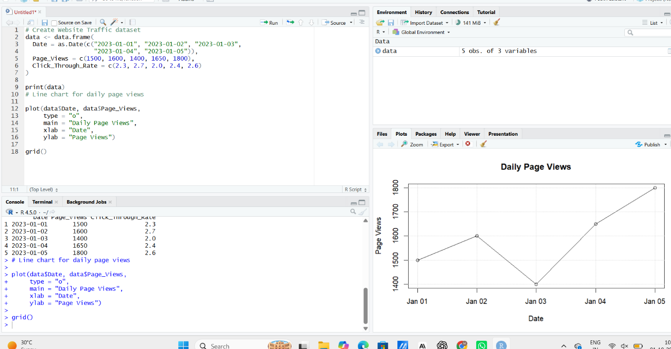
2. Bar Chart – Top N Days with Highest CTR
Aim: To generate a bar chart using R to display the top N days with the highest click-through rates.
Program:
# Find top 3 days based on Click-through Rate
top_n <- 3
top_data <- data[order(-data$Click_Through_Rate), ][1:top_n, ]
# Bar chart
barplot(top_data$Click_Through_Rate,
names.arg = format(top_data$Date, "%Y-%m-%d"),
main = "Top 3 Days by Click-through Rate",
xlab = "Date",
ylab = "Click-through Rate (%)",
col = "skyblue")
grid()
output:
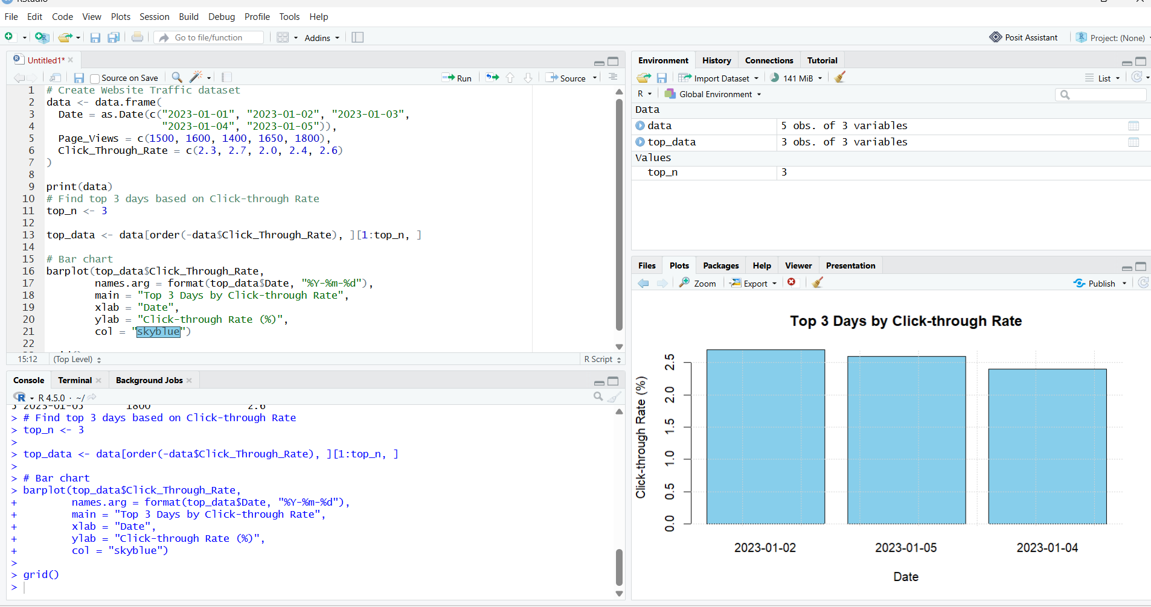
3. Stacked Area Chart – Likes, Shares and Comments
Aim: To develop a stacked area chart using R to visualize the distribution of user interactions such as likes, shares, and comments over time.
Program:
# Website user interaction data
interaction <- data.frame(
Date = as.Date(c("2023-01-01", "2023-01-02", "2023-01-03",
"2023-01-04", "2023-01-05")),
Likes = c(120, 150, 110, 170, 200),
Shares = c(40, 55, 35, 60, 75),
Comments = c(20, 25, 18, 30, 35)
)
# Create matrix
values <- t(as.matrix(interaction[, c("Likes", "Shares", "Comments")]))
# Stacked area chart
plot(interaction$Date,
interaction$Likes +
interaction$Shares +
interaction$Comments,
type = "n",
main = "User Interactions Over Time",
xlab = "Date",
ylab = "Number of Interactions")
polygon(c(interaction$Date, rev(interaction$Date)),
c(interaction$Likes,
rev(interaction$Likes)),
col = "lightblue"
polygon(c(interaction$Date, rev(interaction$Date)),
c(interaction$Likes + interaction$Shares,
rev(interaction$Likes)),
col = "lightgreen")
polygon(c(interaction$Date, rev(interaction$Date)),
c(interaction$Likes + interaction$Shares + interaction$Comments,
rev(interaction$Likes + interaction$Shares)),
col = "pink")
legend("topleft",
legend = c("Likes", "Shares", "Comments"),
fill = c("lightblue", "lightgreen", "pink"))

Output:
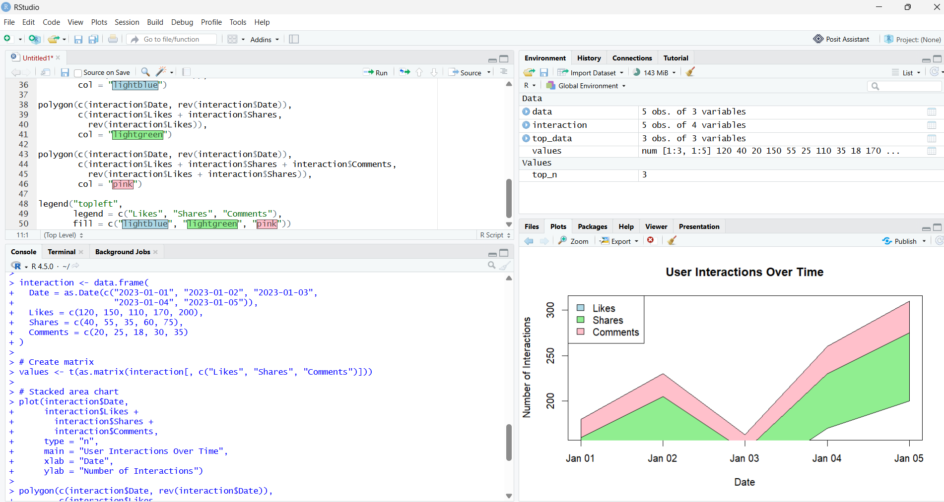

4. Build a Tableau dashboard with the line chart and bar chart for interactive exploration of website traffic data.
Output:
